MetaMoJi ClassRoom Start Guide
This Start Guide shows general procedures for using MetaMoJi ClassRoom in default.
* The guide explains each step using iPad running iOS.
- Login
- Tap to open the ClassRoom app.
- Enter your account information into the Login screen.
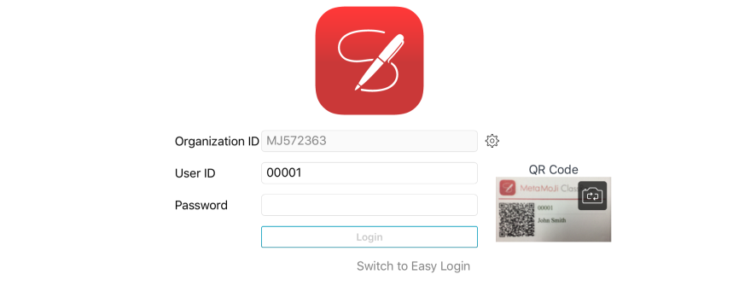
[In case you log in using a QR code]
Pass a delivered QR code from your teacher over the camera on your device.
If the password is not entered automatically, enter your password with the keyboard.
[In case you log in from your class ID number]
Enter your Organization ID.
Tap Switch to Easy Login to select your class and ID number.
* Once logged-in, the Organization ID is saved, and it is not necessary to enter that ID again on that device.
- Opening a Class Note
Open a Class Note which your teacher has placed in the Class Box.

- Find the class folder underneath the Class Box within the folder tree of the Notes List screen.
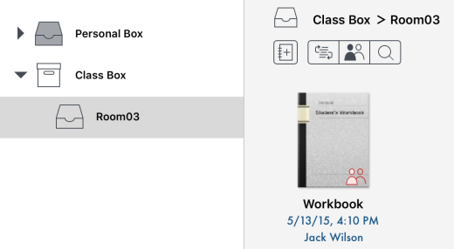
- Tap the Class Note your teacher told you to use.
The note will be opened on the Editor screen.
Tip - You cannot find Class Notes
Tap on the top bar menu to show newly added Class Notes.

- Taking a Class
With the opened Class Note, your teacher starts a class.
During the class, your teacher allows you to fill in the note.
Tap to write and draw on the note. You can add photos, graphics, and web pages from .
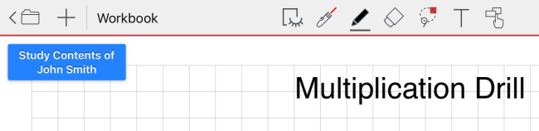
- Leaving a Class
To leave the current class, close the Class Note by tapping .
- Logout
When you finish using the ClassRoom app, tap > Logout at the top right corner on the Notes List screen.
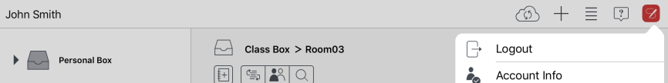
* On the Editor Screen, tap > Logout.

Appendix: Screens
There are two screens within the ClassRoom app when you take a class.

Notes List Screen | Editor Screen
This screen is shown when you log into the app for the first time or when you close a note.  You can see your name in the top left corner. | This screen is shown when you open a note.
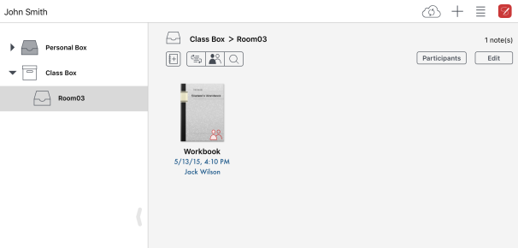 | 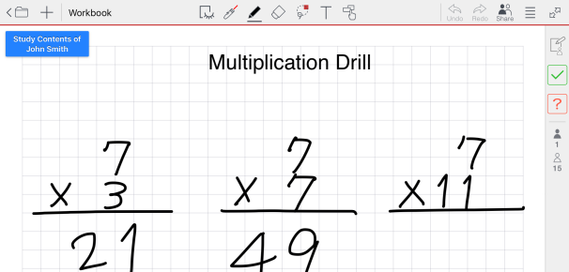
When you tap to open a note, the screen is switched to the Editor screen. | When you tap on the top left corner to close the current note, the screen is switched to the Notes List screen.

